- Tên và phân loại:
- Define an object that encapsulates how a set of objects
interact
- Promotes loose coupling by keeping objects from referring to
each other explicitly, and lets you vary their interaction
independently
- Mục đích, ý nghĩa:

- Động lực sử dụng:
- Consider a font-choosing dialog box
- There are potentially many dependencies between the elements of this dialog
• Clicking one button may effect many other widgets in the dialog
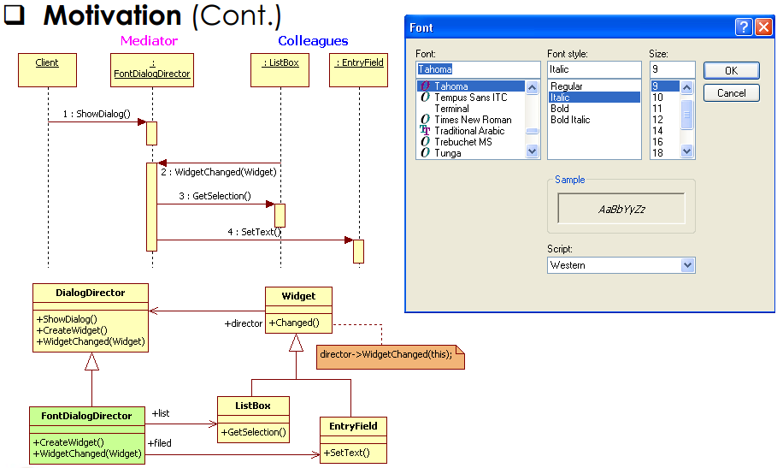
- Khi nào sử dụng:
- A set of objects communicate in well-defined but complex ways. The resulting interdependencies are unstructured and difficult to understand
- Reusing an object is difficult because it refers to and communicates with many other objects
- A behavior that's distributed between several classes should be customizable without a lot of sub-classing
- Cấu trúc
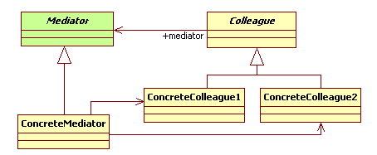
- Các thành viên - Sự cộng tác
- Mediator
• Defines an interface for communicating with Colleague objects
- ConcreteMediator
• Implements cooperative behavior by coordinating Colleague objects
• Knows and maintains its colleagues
- Colleague
• Each Colleague class knows its Mediator object
• Each colleague communicates with its mediator whenever it would have
otherwise communicated with another colleague
- Các hệ quả mang lại:
- Limits sub-classing
• A mediator localizes behavior that otherwise would be distributed
among several objects
• Changing this behavior requires sub-classing Mediator only;
Colleague classes can be reused as is

- Decouples colleagues
• A mediator promotes loose coupling between colleagues
• You can vary and reuse Colleague and Mediator classes independently

- Simplifies object protocols
• A mediator replaces many-to-many interactions with one-to-many
interactions between the mediator and its colleagues
• One-to-many relationships are easier to understand, maintain, and extend

- Abstracts how objects cooperate
• Making mediation an independent concept and encapsulating it in an
object lets you focus on how objects interact apart from their individual
behavior. That can help clarify how objects interact in a system

- Centralizes control
• Trades complexity of interaction for complexity in the mediator. Because
a mediator encapsulates protocols, it can become more complex than
any individual colleague. This can make the mediator itself a monolith
that's hard to maintain
- Chú ý liên quan đến cài đặt:

- Hệ thống thực tế

- Mẫu liên quan
- Facade differs from Mediator in that it abstracts a subsystem of
objects to provide a more convenient interface. Its protocol is
unidirectional; that is, Facade objects make requests of the
subsystem classes but not vice-versa. In contrast, Mediator
enables cooperative behavior that colleague objects don't or
can't provide, and the protocol is multidirectional
- Colleagues can communicate with the mediator using the
Observer pattern

